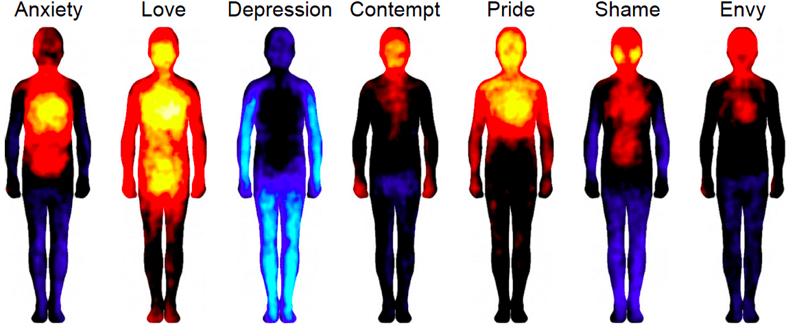
Emotional Body Intuitive Healing

(energy transformation)

Restore your emotional flow state;
What you will learn :
- How to activate your temporal lobes in your brain for balanced energy sensitivity.
- How to use Resonance in healing yourself and others. (Transforming emotions into energy )
2. Learn how to Activate the 7 qualities of your soul
3. Learn how to Sense the emotional energy fields around a person. (Partner work)
4. Learn how to activate the gentle touch, that opens the doorway to the emotional body.
5. Dealing with our dark shields ..that blocks any positive energy coming into your system.
6. Playing with energy -

Energy is energy ....there is no good or bad energy..

What is energy transformation..?
All your aches and pains shame guilts, not good enough, Less thans, anger, martyr, self pity, fears, joy love, happiness , every emotion is comprised of several components that have a resonance and have a form in your body mind sphere as an illness or malady.
When we break the resonance of any emotion or issue, the form of that emotion returns to energy.
Energy is like water, it can be molded and restructured into any form..

Note: we will be doing a lot of partner work.

Locatie:
Kotex Paelwerck 9
Den Burg
Voor meer informatie of aanmeldingen
Alan: 0626861815….. (Engels)
Diana : 06 29021713 (Nederlands)

New students €
Returning students; €

